Problem 5

Main:

x1 = [-4:0.1:4];

y1 = fun(x1);

plot(x1, y1)

hold on

plot([-4,4], [0,0])

x2 = [-2,-1,0,1,2];

y2 = fun(x2)

% Then we found the three intervals of three different root of this function which are: [-2,-1], [-1,0], [1,2]

% Now we want to found the root to six correct decimal places

% for root in [-2,-1]:

f=@(x) 2\*x^3-6\*x-1;

R1=vpa(bisect(f,-2,-1,0.00000005),10)

% for root in [-1,0]

R2=vpa(bisect(f,-1,0,0.00000005),10)

% for root in [1,2]

R3=vpa(bisect(f,1,2,0.00000005),10)

fun.m:

function y = fun(x)

y = 2.\*x.^3-6.\*x-1;

end

bisect.m

The same as textbook

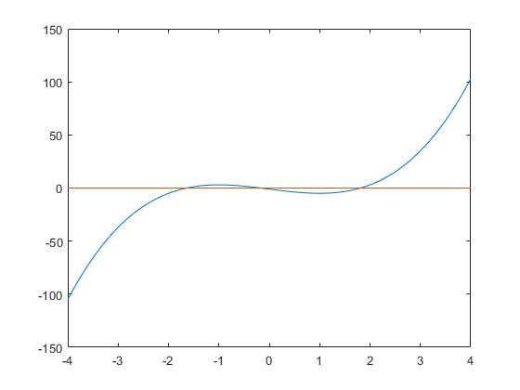Result

y2 = -5 3 -1 -5 3

R1 = -1.641784

R2 = -0.168254

R3 = 1.810038

Plot:

The three intervals of three different root of this function which are: [-2,-1], [-1,0], [1,2]

And the three roots are: R1 = -1.641784, R2 = -0.168254, R3 = 1.810038

Problem 7

Main:

g=@(x) cos(x)\*cos(x)

for j=1:300

If vpa(fpi(g,0,j),7)-vpa(fpi(g,0,j-1),7) == 0

Break

End

End

j

r = vpa(fpi(g,0,j),6)

S = abs(-2\*cos(r)\*sin(r))

fpi.m:

The same as textbook

Result:

j=300

r=0.641714

S=0.959 which is no more than 1

So we can conclude that it’s local convergence, the steps is 300 and the fixed point is 0.641714